Writeup
Advanced Lane Finding Project
The goals / steps of this project are the following:
- Compute the camera calibration matrix and distortion coefficients given a set of chessboard images.
- Apply a distortion correction to raw images.
- Use color transforms, gradients, etc., to create a thresholded binary image.
- Apply a perspective transform to rectify binary image ("birds-eye view").
- Detect lane pixels and fit to find the lane boundary.
- Determine the curvature of the lane and vehicle position with respect to center.
- Warp the detected lane boundaries back onto the original image.
- Output visual display of the lane boundaries and numerical estimation of lane curvature and vehicle position.

Rubric Points

Here I will consider the rubric points individually and describe how I addressed each point in my implementation.

Writeup / README

1. Provide a Writeup / README that includes all the rubric points and how you addressed each one. You can submit your writeup as markdown or pdf. Here is a template writeup for this project you can use as a guide and a starting point.
You're reading it!

Camera Calibration

1. Briefly state how you computed the camera matrix and distortion coefficients. Provide an example of a distortion corrected calibration image.
The code for this step is contained in the first code cell of the IPython notebook located in ".project2 v3.ipynb"
I start by preparing "object points", which will be the (x, y, z) coordinates of the chessboard corners in the world. Here I am assuming the chessboard is fixed on the (x, y) plane at z=0, such that the object points are the same for each calibration image. Thus, objp is just a replicated array of coordinates, and objpoints will be appended with a copy of it every time I successfully detect all chessboard corners in a test image. imgpoints will be appended with the (x, y) pixel position of each of the corners in the image plane with each successful chessboard detection.
I then used the output objpoints and imgpoints to compute the camera calibration and distortion coefficients using the cv2.calibrateCamera() function. I applied this distortion correction to the test image using the cv2.undistort() function and obtained this result:
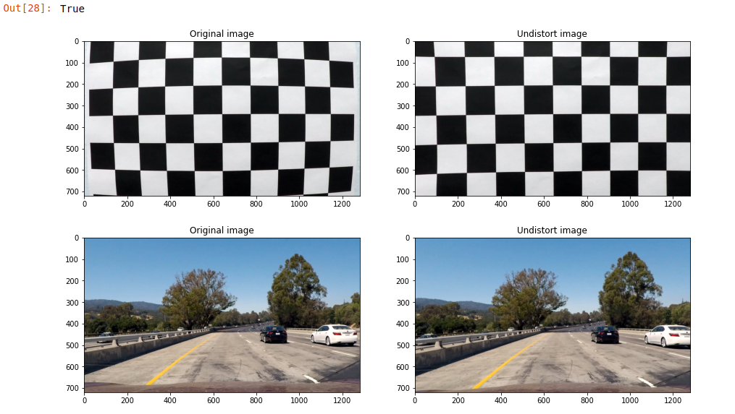

Pipeline (single images)

1. Provide an example of a distortion-corrected image.
To demonstrate this step, I will describe how I apply the distortion correction to one of the test images like this one:

2. Describe how (and identify where in your code) you used color transforms, gradients or other methods to create a thresholded binary image. Provide an example of a binary image result.
I used a combination of color and gradient thresholds to generate a binary image.
thresholding steps:
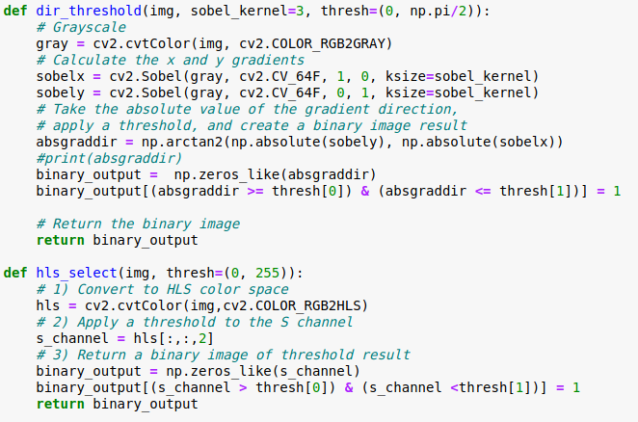

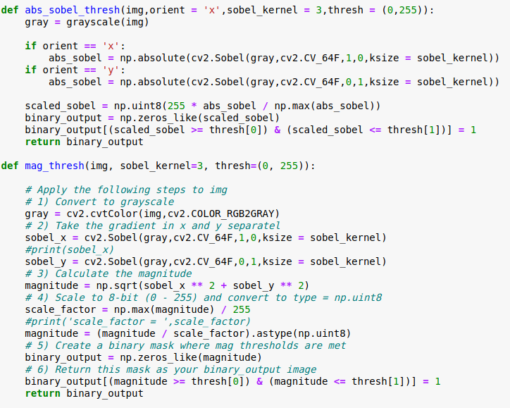
Here's an example of my output for this step.

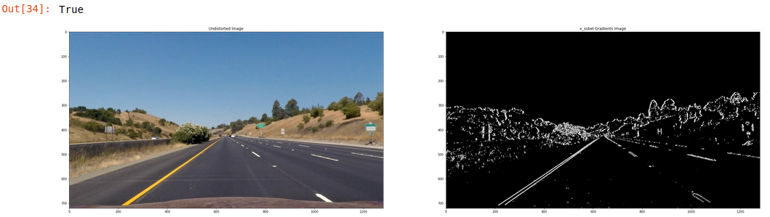
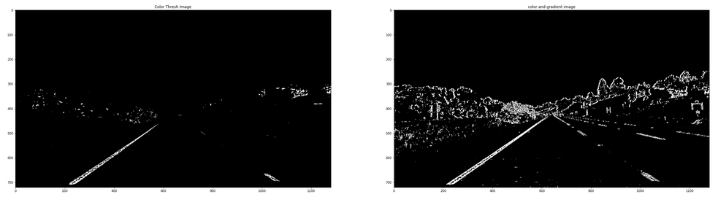

3. Describe how (and identify where in your code) you performed a perspective transform and provide an example of a transformed image.
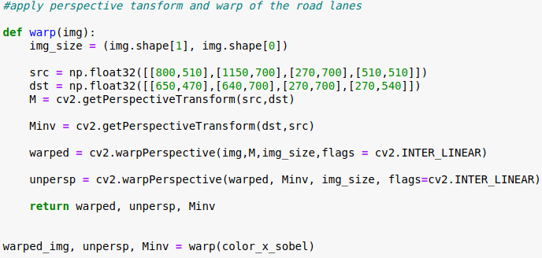

The code for my perspective transform includes a function called warp(). The warp() function takes as inputs an image (img), as well as source (src) and destination (dst) points. I chose the hardcode the source and destination points in the following manner:

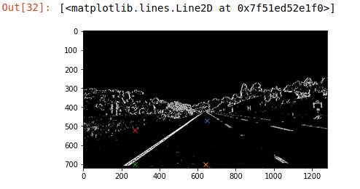
This resulted in the following source and destination points:
Source | Destination
850, 510 | 650, 470
1150, 700 | 640, 700
270, 700 | 270, 700
510, 510 | 270, 540

I verified that my perspective transform was working as expected by drawing the src and dst points onto a test image and its warped counterpart to verify that the lines appear parallel in the warped image.
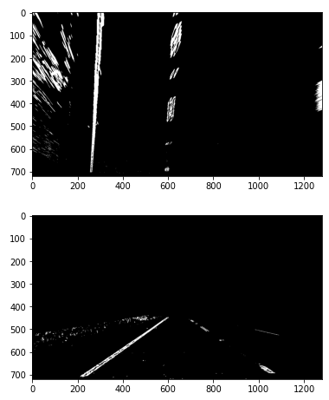

4. Describe how (and identify where in your code) you identified lane-line pixels and fit their positions with a polynomial?
Then I use find_lines() function to detect drive lanes pixels and find lane edges to fit my lane lines with a 2nd order polynomial kinda like this:
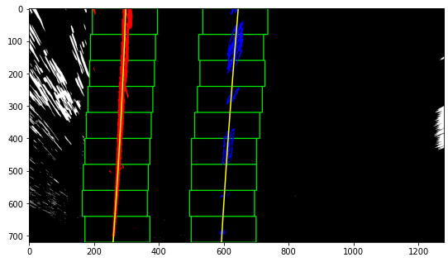

5. Describe how (and identify where in your code) you calculated the radius of curvature of the lane and the position of the vehicle with respect to center.
I use curvature() function to define the curvature of the drive lanes / car to the center.
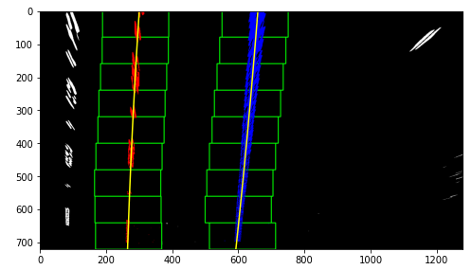
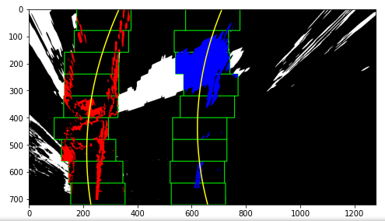
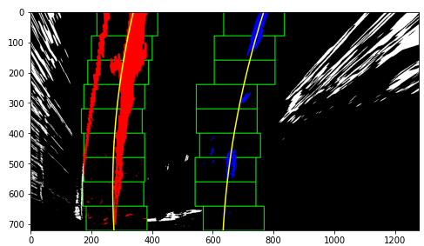
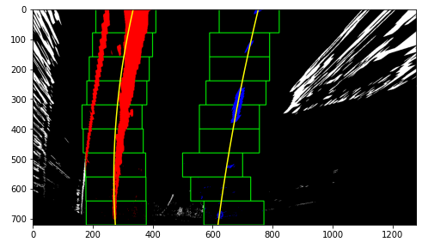
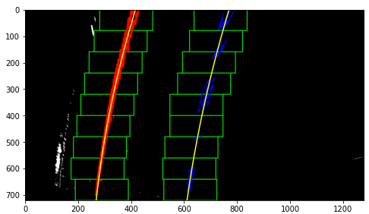
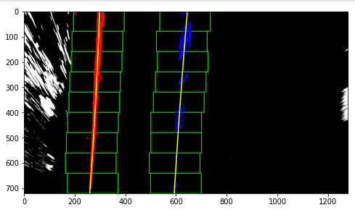
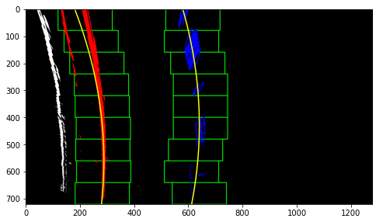
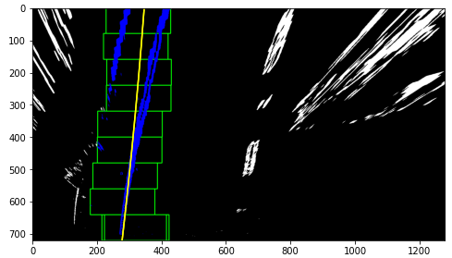

6. Provide an example image of your result plotted back down onto the road such that the lane area is identified clearly.
I implemented this step in my code in the functions show_info() and draw_lines() to twist the edges detected into the original plot and draw lines.
Here are examples of my result on a test image:
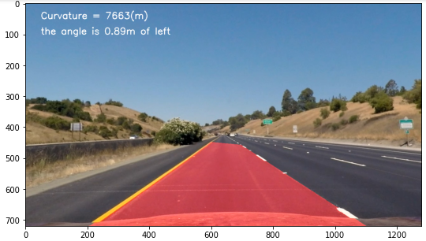
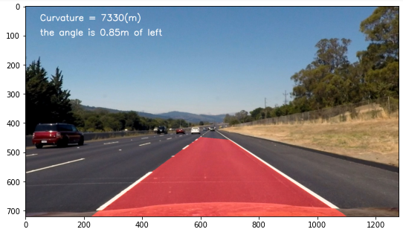
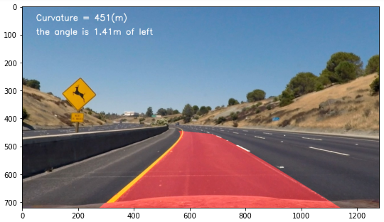

Pipeline (video)

1. Provide a link to your final video output. Your pipeline should perform reasonably well on the entire project video (wobbly lines are ok but no catastrophic failures that would cause the car to drive off the road!).
The video is included in my Github project folder as test_video.mp4.

Discussion

1. Briefly discuss any problems / issues you faced in your implementation of this project. Where will your pipeline likely fail? What could you do to make it more robust?
I found in the video that the outer side of the driver lane when it’s turning can be detected wrongly by my codes. The possible reasons can be that when turning, the lighting environment changed , causing my thresholds not suitable for the clip pics for a sec.

